
2013-2014 U.S.-China Administrator Shadowing Project
OREGON
This program provides school principals and superintendents with a rare opportunity for professional development, personal growth, and intercultural friendship. It is sponsored by The China Exchange Initiative (CEI) and Shaanxi Provincial Bureau of Education, in partnership with the Confederation of Oregon School Administrators (COSA).
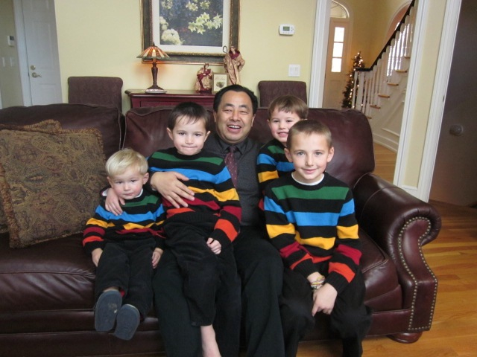
Program Description: The U.S.-China Administrator Shadowing Project is an exchange program for school administrators – superintendents and principals, Chinese and American – with the aim of establishing sustainable school-to-school or district-to-district educational exchange. The Project involves a two-part commitment:
Fall 2013 (October) – Chinese administrators will visit the U.S. After a week attending lectures on American education, visiting state offices such as the Department of Education, and participating in other educational activities and sightseeing in the Boston area, they will shadow partner administrators in Oregon school communities for a week.
Spring 2014 (March) – The Oregon administrators will visit China for a week of seminars and tourism in Beijing and Xi’an, followed by a week of shadowing at their counterparts’ schools. Participants will gain exposure to contemporary Chinese language, culture and society, learn about China’s education system and education reform, and observe the roles and responsibilities of their counterpart school administrators.
Expected Outcomes: Start or enrich a Chinese language program at your school/district; update curricula; and/or create a school-to-school educational exchange with your counterpart in China.
Responsibilities: Program participants are required to participate in the orientation sessions provided by CEI. They are also responsible for scheduling school visits, finding host families and suitable interpreters for professional activities, and arranging school and community activities for their Chinese counterparts during the second week of the program.
Cost: The bulk of program costs will be paid by the China Exchange Initiative, funded by the Freeman Foundation. Participants are required to submit an $1800 participation fee, to offset some cost of hosting Chinese principals for the first week of the program and to defray the cost of American participants’ travel to and in China in the spring. The value of the program is approximately $4500.

The China Exchange Initiative (CEI)  140 Brandeis Road, Newton MA 02459  www.TheChinaExchangeInitiative.org  E-mail: Peihui_Wang@newton.k12.ma.us | Colin Cameron, Director of Professional  Development, COSA  Email: colin@cosa.k12.or.us

