COSA 18-Hole Shot Gun Start
Vendor Golf Registration & Sponsorship

June 20, 2018 – 9:00 am
The Gearhart Golf Links are a great setting to meet conference delegates. Please join us.
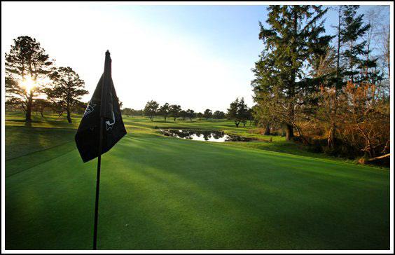
We need your help!
Hole Sponsor - $60
Long Drive - $60
KP - $60
Gifts for All
Tees – Towels – Balls
“Show Your Colors”

Sponsors’ names will be posted at the Convention Center, the Golf Course and on tees sponsored.

I am interested in sponsoring (circle all that apply)
Hole · Long Drive · KP · Gifts
June 20 2017 · 18 Hole Shot Gun Start – 9:00 am
Name Company Handicap
Email
☐Place me in any group
☐I would like to play with (I have confirmed with my partners)

Handicap Handicap
Handicap Handicap
If you do not have a handicap, you may use the score for 18 holes ___
Send to Meghan – meghan@cosa.k12.or.us

