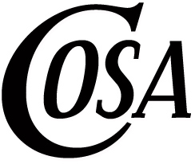
CONFEDERATION OF OREGON SCHOOL ADMINISTRATORS
707 13TH STREET SE, SUITE 100, SALEM, OREGON 97301
TELEPHONE (503) 581-3141
FAX (503) 581 9840

2019 Bev Gladder Mentorship Award

Purpose:
Annual recognition of a COSA member who has distinguished him/herself within the profession as a mentor to aspiring or new school administrators.

Selection Criteria:
The award recipient must:
- Be an active COSA member
- Have demonstrated a commitment to mentoring over time by providing support to more than one new or aspiring administrator
- Be known to teach, advise, sponsor, support and otherwise aid new or aspiring school administrators
- Model exemplary leadership, ethics and professionalism consistent with the highest standards of Oregon’s public school administrators
- Volunteer time beyond scope of paid or assigned professional duties to offer mentoring support for new or aspiring school administrators
- Be nominated by a peer or beneficiary of the mentoring support recognized by this award

Nominating Process:
Individuals seeking to present a nominee for the 2019 Bev Gladder Mentorship Award should submit a letter of not more than two typewritten pages listing the name and position of the nominee and a statement noting how the nominee meets the selection criteria for the award.

- Nomination letters should be mailed to the following address:
Confederation of Oregon School Administrators
Attn: Joanne Fey
707 13th Street SE, Suite 100
Salem, Oregon 97301-4035
- Nomination letters must arrive at the COSA office no later than May 1, 2019.

Award Presentation:
The 2018 Bev Gladder Mentorship Award will be presented in June at a General Session during the annual COSA Conference in Seaside.

