Collaboration Captain #1 – SISKO Partner Name______________________
Reflect on and list your “must do’s.”

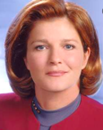Collaboration Captain #2 – JANEWAY Partner Name______________________
Reflect on and list your “should do’s.”

Collaboration Captain #3 – KIRK Partner Name______________________
What is your “Why?” – “Want to do’s?” – Personal non-negotiables for YOURSELF.

Captain Collaboration at your tables:

- How will you “bring you” to your school every day?

- How will you leverage “being you” and being vulnerable to complete the should and must do’s (AND all the new learning from this conference)?

