Richard Elmore

Gregory R. Anrig Research Professor of Educational Leadership
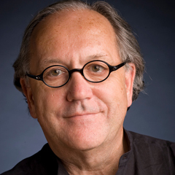
DEGREE: Ed.D., Harvard University, (1976)
EMAIL: richard_elmore@gse.harvard.edu
FACULTY ASSISTANT: Tilman Freitag

Profile
Richard Elmore joined the faculty of the Harvard Graduate School of Education in 1990, having previously taught at the College of Education, Michigan State University, and the Graduate School of Public Affairs, University of Washington. He is a member of the National Academy of Education, and a past president of the Association for Public Policy and Management, the national organization representing graduate programs in public policy and management. He has held positions in the federal government as a legislative liaison with the U.S. Congress on education policy issues. He is currently director of the Doctor in Educational Leadership (Ed.L.D.) program at HGSE. His current research and clinical work focuses on building capacity for instructional improvement in low-performing schools. He spends at least one day per week in schools, working with teachers and administrators on instructional improvement. He is coauthor of Instructional Rounds in Education: A Network Approach to Improving Teaching and Learning (Harvard Education Press, 2009), and author of School Reform From the Inside Out: Policy, Practice, and Performance (Harvard Education Press, 2004).

