NOTICE OF VACANCY OPPORTUNITY

An Invitation to Apply for the Position of
Superintendent

The Glendale School District Board of Directors is seeking an innovative, student-centered superintendent who is ready to lead a small, tight-knit district beginning July 1, 2026. The successful candidate will be a collaborative leader who communicates clearly, builds strong relationships, and champions a culture where every student is known, supported, and encouraged to thrive.


Location: Glendale, Oregon | Enrollment: 300
Salary: $130,0000 to $150,000 annually plus benefits

Closing Date: January 30, 2026 | Start Date: July 1, 2026

Mission statement
We aspire to be a district that successfully educates all students by unleashing their potential and empowering them to be their best. We are a district that values our educators and staff through fairness and respect, freeing them to accomplish their assigned tasks. We will work endlessly to produce college and work-ready adults who contribute to society with confidence, compassion, and knowledge. Our collective efforts will inspire those, both from within and outside our district, to seek safe harbor in our ocean of knowledge.

THE POSITION
The successful candidate must hold or qualify for an Oregon administrator license or be in the process of obtaining it. The district is looking for someone who can guide long-term planning, strengthen community partnerships, and support dedicated staff while keeping students at the heart of every decision. This is an excellent opportunity for a leader who values rural schools, hands-on engagement, and the ability to make a meaningful, visible impact.

THE QUALIFICATIONS
The board of directors seeks a career driven, committed individual to fill the role of District Superintendent. This individual must be a strong educational leader who has the following professional experience and training:

Leadership & Vision
- Is visible and involved in the schools and community
- Builds collaborative working relationships with staff, parents and community
- Demonstrated ability to develop a clear, student-centered vision
- Prioritizes efforts to raise Glendale K-12 scores to levels that compete statewide or above.
Experienced Administrator and Educator
- Values and respects the contributions from all staff members
- Brings fresh ideas and innovation to solving problems and improving the district
- Demonstrates solid budgeting skills and understands school finances
- Successful experience as an educational leader and administrator; has a background in the classroom and other administrative experience
- Builds partnerships with families, community, local government and higher education
Communication Skills
- Communicates effectively in multiple formats
- Is accountable and transparent
- Approachable, personable communication style
- Ability to build trust with staff, families and community
- Communicates effectively with the board.
Personal and Professional
- Demonstrates a strong personal and professional integrity
- Committed to being an active member of a small, rural community
- Values collaboration, visibility and positive relationships
- Consistently meets deadlines by planning work effectively, prioritizing responsibilities, and delivering accurate results on time without the need for follow-up or reminders.
- Prefer a candidate who will be willing to relocate no further than 30 miles from our district.

THE COMMUNITY

Nestled in the beautiful hills of southwest Oregon, on the I-5 Corridor, with a population of just under 900, Glendale offers the charm of small-town living where people look out for one another, and the schools serve as a central hub for community life.

Outdoor recreation is right at your doorstep - forests, rivers, and trails invite year-round adventure and the town’s historic roots in timber and rail create a unique character that residents embrace.

Families, local businesses, and civic partners actively support the district, creating a welcoming environment for a superintendent who values strong relationships and being part of a close-knit, engaged community.

THE DISTRICT

The district operates two schools - Glendale Elementary and Glendale Jr./Sr. High - together educating approximately 300 students.

Staff and families describe the district as a place where relationships matter, students are supported as individuals, and school events are truly community events.

With small class sizes, committed educators, and a community that rallies around its schools, Glendale offers an environment where a superintendent can lead with purpose, connection, and creativity. The district is focused on academic growth, career and technical learning opportunities, and maintaining a positive and inclusive school culture.

To learn more about Glendale School District, visit the Glendale School District website.
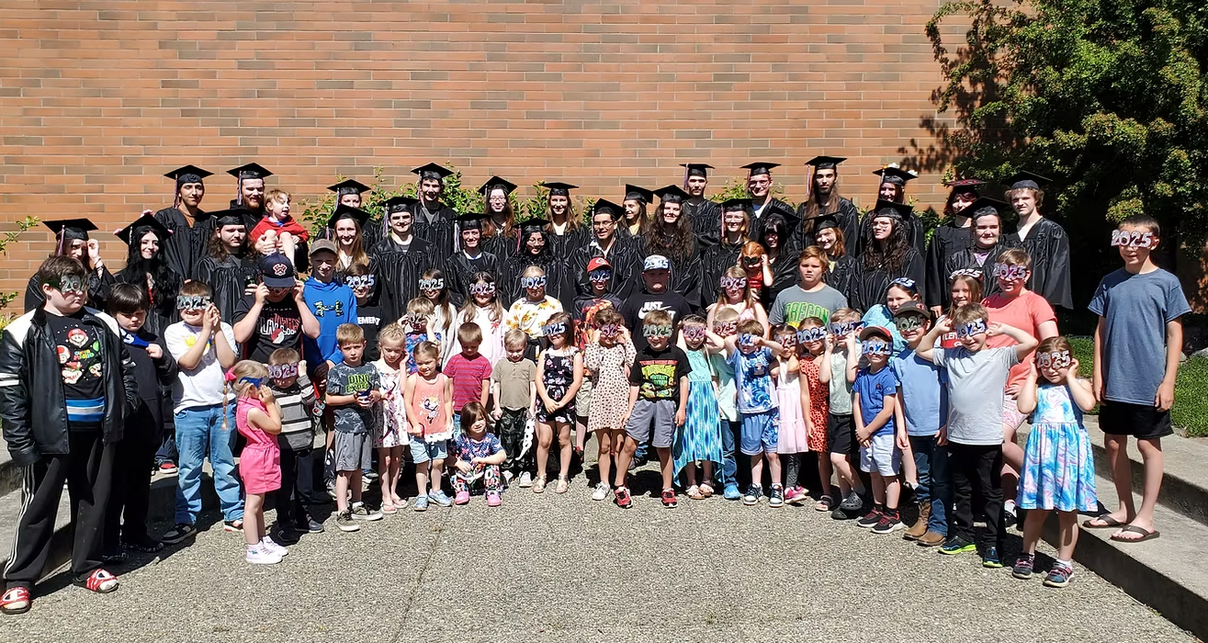

Application Requirements
- Completed application
- Current resume
- Cover letter of interest
- Three to five current letters of recommendation
- Be willing to spend a half day on campus

How to submit an application….
Application packets are submitted through Frontline Recruiting & Hiring (link below). All applicants must submit a completed application, as well as upload the other application documents to the application portal.

CLICK HERE TO APPLY: If the link is not opening, here is the web address to copy and paste into your browser: https://tinyurl.com/43jy47ns

TIMELINE
CLOSING DATE
January 30, 2026

APPLICATION SCREENING
Screening – February 1, 2026, thru February 9, 2026
Selection of Candidates – February 10, 2026
Half day on campus – February 11th, 12th, or 16th.

INTERVIEWS
February 17, 2026

Final Selection
Will be notified February 19, 2026

Public Announcement of New Glendale District Superintendent
March 18, 2026 (At March Board Meeting)

