The School Board

Andy Wright, Chair
Kailey Clarno, Vice Chair
Scott McNair
Nancy Sorensen
Jeremy Skinner

Challenges and Opportunities

- Effectively develop and articulate a shared vision of success and serves as the lead learner of the school.
- Engage the school community in collaborative processes toward a vision of excellence.
- Ensure effective and excellent parent communication, engagement, and outreach by maintaining welcoming and positive relations with parents
- Create a welcoming, disciplined and joyful school culture with high standards of behavior and a culture of respect, kindness, and inclusion.
- Oversee the teaching and learning program, including scheduling and class assignments, curriculum, lesson planning, professional development, assessment and accountability.
- Develop new career pathways and diversifying educational opportunities with higher education and community partnerships.

About the Community

Central Curry School District serves the southern Oregon coast centered on the community of Gold Beach. Gold Beach has a population of 2500 and sits at the mouth of the world famous Rogue River; a sporting enthusiast’s paradise. This part of the Oregon coast is particularly beautiful and opportunities abound for hunting, fishing, rafting, hiking or windsurfing and generally great for enjoying the out-of-doors.
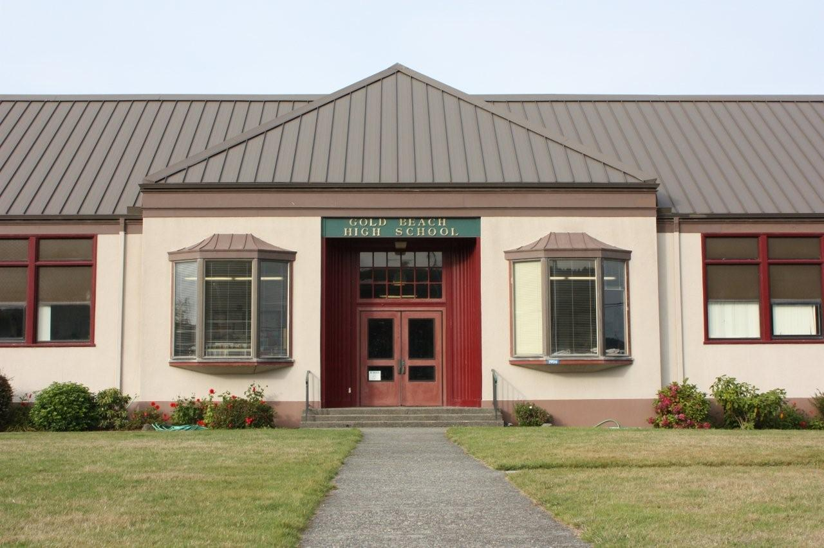
Although rural in nature, Gold Beach is the county seat of Curry County and is home to a new state of the art regional community hospital. Brookings, a larger Oregon town of 6500, is a mere 30 minutes to the south. Gold Beach has a Mediterranean climate with relatively warm and dry summers. Winters rarely, if ever, drop below freezing. Numerous festivals punctuate the year including the South Coast Writers Conference, Brew and Art Festival, the Fourth of July Festival and “Whale of a Wine Fest” to name a few.

From the moment you arrive, you’ll recognize a town with a definite community feel and a sense of the ownership and pride. Gold Beach is a wonderful place to raise a family and have a career.
Central Curry School District
Leadership Profile
and
Position Description
January 2021

Job Title: Riley Creek
Elementary Principal

District: Central Curry School District #1

Location: Gold Beach, Oregon

About the position

The Central Curry School District #1 Board of Directors is seeking a full-time principal, to replace Tom Denning, who will be continuing as half time superintendent.

This is an excellent leadership opportunity for the right candidate. The board of directors is seeking an educational leader who has the ability and energy to collaboratively lead Riley Creek Elementary School. The board seeks candidates who can support the learning of students, engage parents and the community, be open, be honest, and be supportive of teachers and can communicate a compelling vision for the school and its role in the community.

About the District

The Central Curry School Districts serves approximately 440 students. This beautiful district on the Southern Oregon coast has a committed and engaged board of directors who desire an equally committed individual to lead Gold Beach High School, an individual that will reflect and amplify the pride the community feels for GBHS.

The district consists of one elementary school (K-8) and one secondary school (9-12) in Gold Beach. The Gold Beach High School campus is situated on a hill overlooking the Pacific Ocean. As one would expect, the community supports the district both financially and with their volunteerism. Gold Beach natives and newcomers alike want the school to thrive and prosper.
Besides the elementary school principal, the district also employs an experienced principal at the high school and a superintendent.
Compensation

The Board is interested in someone who is willing to commit to the district for a number of years and will consider a multi-year contract with salary and benefits commensurate with other similar-sized districts and based on the candidate's experience and abilities.

Desired Qualities and Characteristics

The Board of Directors, staff and community are seeking candidates with the following qualities and characteristics:

- Committed to the area, someone who is a good fit.

- A collaborative leader who is fair and consistent, someone who implements policy uniformly and treats all employees and students with respect.

- Demonstrates a passion and ability to address instructional excellence, student achievement and placing students first in all decisions.

- A leader who can establish a vision for the school, communicate it with the community, and build trust and cooperation throughout the process.

- Fosters a culture that expects the best of both students and staff.

- Exhibits a strong interest in students and student activities.

- Maintains a high degree of visibility within the community and schools to include active participation and involvement in school and community activities.

Application Procedures/Timeline

A completed application packet should include:
- An Administrator Application
- A letter of interest in the position
- A statement explaining how the candidate’s experience and training prepares him/her to address the challenges outlined in this posting (maximum of one page per challenge)
- A resume including information about potential references
- Four letters of recommendation
- A copy of a current Oregon Administrator License

Applications are due February 8, 2028, however, the district retains the option of accepting applications until the position is filled.

All application materials should be sent to:

Tim Wilson, Superintendent
Central Curry School District
29516 Ellensburg Avenue
Gold Beach, OR 97444
twilson@ccsd.k12.or.us
541-247-2003, ext. 224

